** Featherstone News**

**October 2019**

Dates:

Wednesday 16th Oct – Getting to know you trip to Sutton Park by train for children and their families

21st to 25th Oct – Children of the World Week

Wednesday 23rd Oct – Parent workshops at

8.40am & 12.40pm

28th Oct – 1st Nov – Half term holiday, nursery closed

Monday 4th Nov – INSET Day – staff training, nursery closed to children

Week beginning 11th Nov – Individual parent/carer meetings with keyworkers

18th – 22nd Nov – Nursery Rhyme Week – We’ll be learning lots of nursery rhymes this week, which are great for developing children’s language skills.

Wednesday 20th Nov – Parent workshop focussing on how children learn in nursery and ways you can support their learning at home.

****

Nursery News:

A huge welcome to all our new families and children and a welcome back to those of you who were part of the Featherstone Community last year!

We hope you all enjoy this year at nursery. If you have any questions

or suggestions, please speak to

your child’s keyworker.

All the children are now settled in at nursery. They are busy learning

how to play with each other,

take turns, share the toys and

ask for help when needed.

****

**C:\Users\sharo_000\AppData\Local\Microsoft\Windows\Temporary Internet Files\Content.IE5\E8W8IYMI\MC900441902[1].wmf**

**C:\Users\sharone\AppData\Local\Microsoft\Windows\Temporary Internet Files\Content.IE5\NEZO30YH\MC900436041[1].wmf**

Children’s Coats

Please encourage your child to hang up their own coat on their peg when they arrive at nursery as this

supports the independence

skills they are learning.

Also please put names in their coats (and hats, gloves and jumpers) as we have many that are the same.

Please ensure that you keep spare clothes for your child in their bag at all times so we can changes them if needed. Also please do not put any food items in their bags and

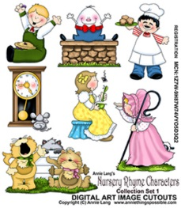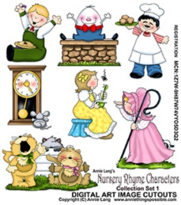**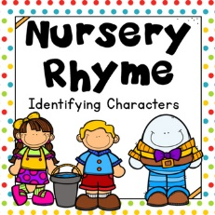**



Hello from the new leadership team

If we haven’t met you already please come and introduce yourselves to our new senior leadership team.

Head Teacher – Sharon Eeles

Deputy Head Teacher – Angela Blacker

Special Educational Needs Co-ordinator (SENCo) – Alison Hollins

You’ll find at least one of us at the school at all times

Children’s Bags

Please ensure that you keep spare clothes for your child in their bag at all times so we can change them if needed. If you have any nursery clothes at home please return them as soon as possible.

Also please do not put any food

items in their bags as we have

some children in nursery with

food allergies.





**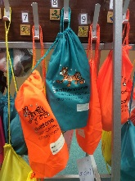**

Please remember to telephone us on 675 3408

if your child is too ill to be at nursery.

**C:\Users\sharone\AppData\Local\Microsoft\Windows\Temporary Internet Files\Content.IE5\NSVKJDB4\MC900434383[2].wmf**



**Rights Respecting Schools Award (RRSA)**

We have achieved the Silver Level of the Rights Respecting Schools Award (RRSA) and as part of this award we work with the children as well as with you to raise awareness about the UN Convention on the Rights of the Child.

Our returning children have already met **Stripey our rights respecting tiger**

but all new children will also be introduced to him. He will help them learn about their rights through different activities.



Looking after Stripey at Home

As part of embedding children’s rights in our policies and practice we will be sending home Stripey to help your child learn about their own rights and how to respect the rights of others and would like you to support us and your child’s learning by looking after him when he comes to visit.

Stripey will spend a few days at your home and then come back to nursery to tell us about his adventures. Here are some of the other rights we would like you and your child to talk about:

* **Right to be safe from harm (Article 19)**
* **Right to healthy food, clean water, healthcare (Article 24)**
* **Right to celebrate and join in different activities (Article 30)**
* **Right to relax and play (Article 31)**

You can write, draw or document in the diary what happened whilst Stripey was visiting your family in whichever way you like. Your child will have time to share these experiences with the group and explain how the rights were met. You can have a look at what your keyworker has written and how they have related the experiences to the rights of the child.

This activity will be explained more at the workshop on Wednesday 23rd October as part of Children of the World Week.





C:\Users\sanam.OSBORNEN\AppData\Local\Microsoft\Windows\Temporary Internet Files\Content.IE5\H59UR2ET\food-grilled-cheese[1].png

Children of the World Week - 21st to 25th October

Our families come from a wide range of heritages. This week will be a time to celebrate this and share our cultures with our friends and learn about other families’ traditions, stories and foods.

We would like families to share things from their cultures – special objects, stories, games or food. If you could help us with this please speak to your key worker.

As part of this week on Wednesday 23rd October we will be having a Parent Workshop focussing upon UNICEF’s children’s rights. You will also get to taste lots of food from around the world.

We would like to encourage our children to come to nursery on any day this week dressed in their traditional costumes or the colours of the flags their families originally came from.



Parking Outside Nursery

Please be respectful of our neighbours when parking outside nursery. Please make sure

that you do not park in the resident only parking bays in Boundary Road.