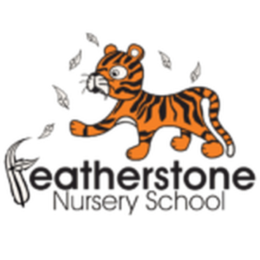 **Featherstone News**

**November 2021**

Dates:

Wednesdays in Nov & Dec – Sally, our artist in residence, will be working with our 3-4 year olds in nursery

15th – 19nd November – Nursery Rhyme Week – What is your child’s favourite nursery rhyme?

15th – 19th – National Road Safety Week

WC: 6th December – Wear your Christmas jumpers or something red! ‘Save The Children ‘ charity.

Tuesday 14th and Thursday 16th – Christmas dinner.

Wednesday December 15th 2021 – Christmas parties!

Friday 17th December – Children break up from Nursery

Tuesday 4th January 2022 – INSET Training Day for staff, **nursery closed** for children

Wednesday 5th January 2022 – Children return to Nursery

 

Nursery News:

We have been learning about Diwali this week. The children have enjoyed listening to the story all about Rama and Sita. We would like to wish all of our families a very happy Diwali!

We have been exploring our outdoor environments and have made many improvements to the areas. The children have enjoyed seeing photographs of themselves in the different areas – playing on the bikes, creating structures and mixing in the mud kitchen!

As the weather turns colder please make sure that your child wraps up warm with a coat, hat and gloves. We play outside whatever the weather!

Please remember to telephone us on 675 3408 if your child is too ill to be at nursery. 

Please take time to read our new OFSTED report – you will find the link on Tapestry .We are really proud of our achievements.

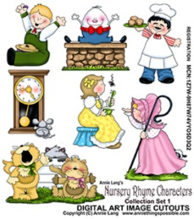

Resources:

We are collecting **EMPTY**, **CLEAN** yogurt pots – if you have any yogurt pots please bring them into Nursery.

We have a mud kitchen in our outdoor area and we love to make potions! If you have any flowers that were once beautiful but are wilting please could we have them? The children love to explore the textures and colours and mix them into a magic potion! We will leave a bucket by the front entrance for any flowers you can donate. 

Forest School 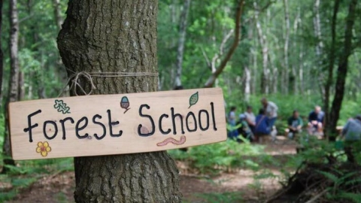

Forest School sessions will begin again WC -8th November. These sessions will be on a Wednesday or Friday. Please keep an eye out for messages on Tapestry. We can provide waterproofs and wellies but you can bring your own if you would like to. Please ensure all items are named. Forest School sessions promote independence and the children really enjoy the activities shared. Look out for photos!

Parking Outside Nursery

Please be respectful of our neighbours when parking outside nursery.



**Rights Respecting Schools Award (RRSA)**

We have achieved the Silver Level of the Rights Respecting Schools Award (RRSA) and as part of this award we work with the children as well as with you to raise awareness about the UN Convention on the Rights of the Child.

Our returning children have already met **Stripey our rights respecting tiger**

but all new children will also be introduced to him. He will help them learn about their rights through different activities.



Safeguarding

If you’re a motorist then you’ll know how difficult it can sometimes be to see pedestrians wearing dark clothes at night or when visibility is poor. Your child will be learning the road safety message **‘Be Safe, Be Seen’** at nursery this month and it’s important that you as a parent or carer help your child to be easily seen near traffic, as well as setting an example to your children by wearing something bright or white too.

**How can my child be seen more easily?**

**1. On dull days your child can wear bright or fluorescent colours**

* Special high-visibility tabards and other clothing can be bought from many retailers
* Fluorescent armbands can also be worn over coats and other clothing
* Bags are also available in bright colours or with high-visibility strips

**2. If walking near traffic at night reflective clothing is needed**

* Reflective clothing reflects light from car and bike headlamps
* Reflective armbands and clothing can be bought for children
* Remember that fluorescent colours do not show up in the dark

Balance Bikes and Stripey

The children have really enjoyed taking the balance bikes home! We will be continuing to lend our nursery balance bikes, so please allow your child to take one home when it is their turn and let us know how they get on.

Stripey will continue to come home too!

World Nursery Rhyme Week: 15th - 19th November

Nursery rhymes are great for children to learn as they help them tune into the sounds of words and teach them new vocabulary. Both of these are essential for children’s early reading skills. We’ll be doing lots of rhymes with your child in the coming weeks.

Parents, how many nursery rhymes can you remember? Ask your key worker if you need some ideas. Say them with your child and emphasise the rhyming words at the end of each line.

Please speak to your child’s Key Worker about joining us for a session. 