** Featherstone News**

C:\Users\sharone\AppData\Local\Microsoft\Windows\Temporary Internet Files\Content.IE5\NEZO30YH\MC900363604[1].wmf**C:\Users\sharone\AppData\Local\Microsoft\Windows\Temporary Internet Files\Content.IE5\NSVKJDB4\MC900022721[1].wmf November 2019**

Nursery News:

As the weather turns colder

please ensure your child has a coat

and appropriate outdoor clothes (gloves, warm hat, wellies) with them each day as they do play outside every day, whatever the weather.

Dates:

Week beginning 11th Nov – Individual parent/carer meetings with keyworkers

18th – 22nd Nov – **Nursery Rhyme Week** – We’ll be learning lots of nursery rhymes this week, which

are great for developing children’s language skills.

Tuesday 19th Nov – Hedgehogs & Robins parents **join your child** at their story time (2.10pm)

Thursday 21st Nov - Parents **join your child** at their story time (11.10am, 2.10pm or 3.10pm – ask your keyworker for your group’s time.).

13th & 16th Dec – **Christmas dinners**

Tuesday 17h Dec – Hedgehogs & Robins parents join your child at their story time (2.10pm) for a Christmas sing-a-long

Thursday 19th Dec - Parents join your child at their story time (11.10am, 2.10pm or 3.10pm – ask your keyworker for your groups time.) for a Christmas sing-a-long

Wednesday 18th Dec – **Christmas parties** in am and pm sessions

23rd Dec to 3rd Jan - **Christmas holidays**

Monday 6th Jan – INSET Training Day for staff, **nursery closed** for children

www.featherstonenurseryschool.org.uk





Cool Kittens for October

With the best attendance were

**Rabbits am Group**

with 90%

average attendance



World Nursery Rhyme Week: 18th - 22nd November

Nursery rhymes are great for children to learn as they help them tune into the sounds of words and teach

them new vocabulary. Both of these are essential for children’s early reading skills. We’ll be doing lots of rhymes with your child this week.

Parents, how many nursery rhymes can you remember? Ask your key worker if you need some ideas. Say them with your child and emphasise the rhyming words at the end of each line.

Join your child this week at their storytime for a special rhyme time session.

Beginning of the week children – Tuesday

Everyone else – Thursday

* Am children 11.10am
* Pm children 3.10pm
* 2.5 days / 30 hrs children 2.10pm



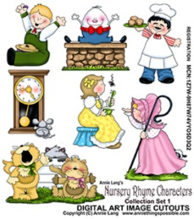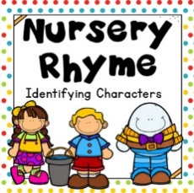

Parent Meetings with Keyworkers

Please remember to come for your individual parent/carer meeting with your keyworker this month.

These meetings are a time to discuss your child’s progress in detail and let you know how you can support their learning at home.

Safeguarding

If you’re a motorist then you’ll know how difficult it can sometimes be to see pedestrians wearing dark clothes at night or when visibility is poor. Your child will be learning the road safety message **‘Be Safe, Be Seen’** at nursery this month and it’s important that you as a parent or carer help your child to be easily seen near traffic, as well as setting an example to your children by wearing something bright or white too.

**How can my child be seen more easily?**

**1. On dull days your child can wear bright or fluorescent colours**

* Special high-visibility tabards and other clothing can be bought from many retailers
* Fluorescent armbands can also be worn over coats and other clothing
* Bags are also available in bright colours or with high-visibility strips

**2. If walking near traffic at night reflective clothing is needed**

* Reflective clothing reflects light from car and bike headlamps
* Reflective armbands and clothing can be bought for children
* Remember that fluorescent colours do not show up in the dark

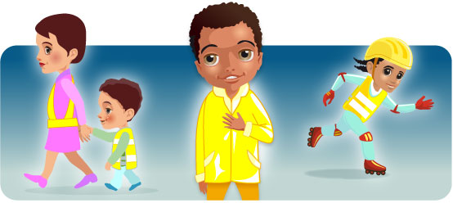

School Fund

Thank you to all the parents who are paying their school fund of £1 a week. In light of tightening school budgets, this enables us to pay for regular items such as breakfast, fruit snack, spare clothes and resources for celebration days. In previous years it has also been used to

purchase gardening seeds, cooking ingredients and subsidise trips.

Please put any voluntary donations to school fund in the red letterbox by reception.

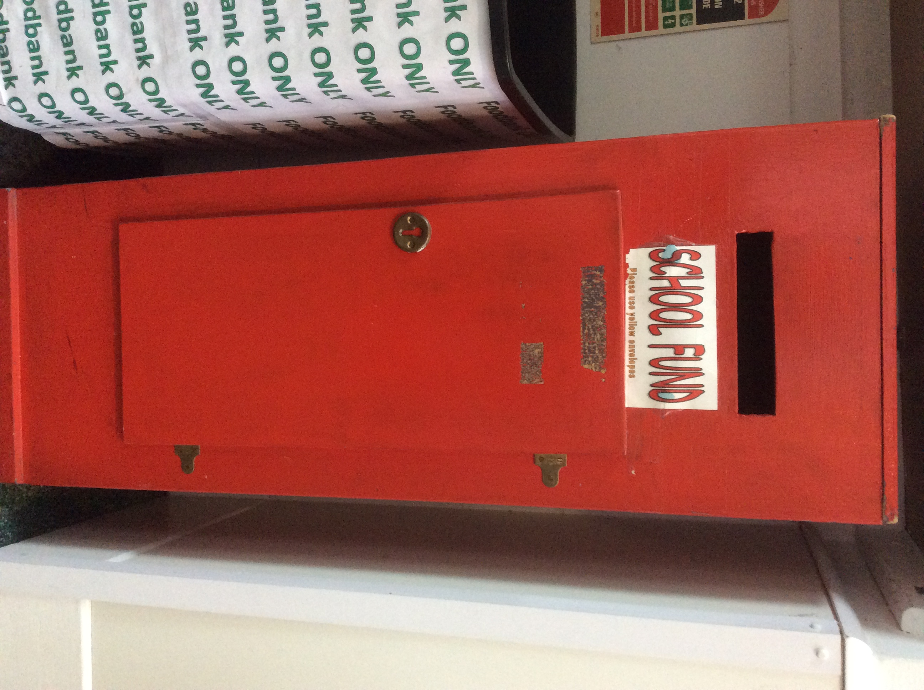

3-4 year olds

We’re practising sharing and waiting for our turn. Sharing teaches children about compromise and fairness. They learn that if we give a little to others, we can get some of what we want as well. Children who share also learn how to take turns and negotiate, and how to cope with disappointment. These are all important life skills.

You can help us at home by pointing out good sharing in family members and giving your child lots of praise when they try to share or wait their turn. Try playing a board game that involves turn taking.

**Things we are learning at nursery**

**and ways you can help us at home**

2 year olds

We’re doing lots of activities that build up our core strength so that we can sit still, balance and have control over our movements (all skills needed for writing when we’re older)

You can help us at home by giving us lots of opportunities to jump, climb, crawl and bounce. Taking us swimming or riding a balance bike is great too!



Parking Outside Nursery

Please remember that this month the council will be replacing the streetlights in Highcroft Road. Please avoid parking here when dropping off and collecting your children from nursery.