** Featherstone News**

**March 2023** 

Nursery News:

The Playhouse was a lovely experience for our children. They really enjoyed Grace’s storytelling and learning all about the adventures of Anansi. This inspired many of our children to write their own wonderful stories. 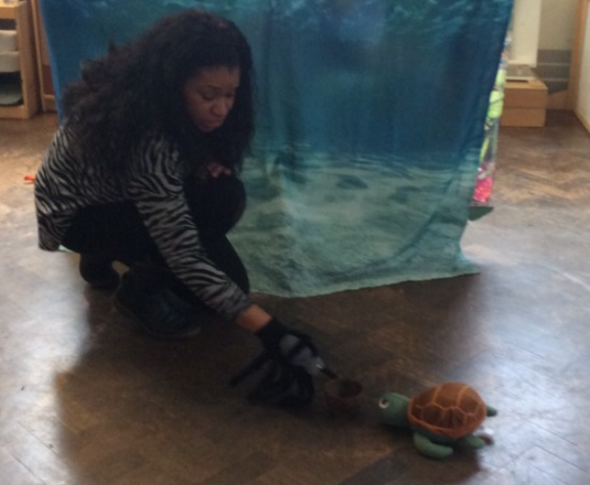

Dates for your diary:

Wednesday 1st March 2023 – Dressing up as our favourite book character for World Book Day! Reading workshops 3-4 year olds Tuesday 28th February 1.45 – 2.30pm OR 2.45 – 3.30pm OR Thursday 2nd match 10.45 – 11.30 am

Early Words Together – Starts again on with Menaz on Tuesdays.

Wednesday 8th March – STAFF TRAINING – Nursery closed for children.

Wednesday 15th March and Wednesday 22nd March 2023 - Sally our artist is back! Look out for workshops dates

Wednesday 29th March 2023 : Featherstone’s Spring Fair from 2:30pm – come and join us!

Easter holiday – Monday 3rd April– Friday 14th April 2023

Nursery open on Monday 17th April 2023

 Attendance is very important at Nursery. We like to see you for all of your sessions each week. We like families to aim for attendance to be between 95 and 100%. Look out for the Cool Kittens stickers

Congratulations to ROBINS – 95% (a close second SQUIRRELS)and LADYBIRDS PM 82% for the best attendance in Nursery in January 2023. FANTASTIC!! Well done to the parents and carers too. Aim for 95% or above!!

Contact

**Contacting Nursery: Please remember to telephone us on 675 3408 if your child is too ill to be at nursery.** Please keep us updated with any changesof address or phone numbers. Please let the Rachel or Rebecca know at our office.

Cold Weather:

PLEASE remember to send your child to Nursery in a NAMED warm coat, gloves and a hat. Please supply a change of clothes too – sometimes the children may get wet or dirty and we will change them into dry, clean clothes when needed. Thank you.



**Rights Respecting Schools Award (RRSA)**

We have achieved the Silver Level of the Rights Respecting Schools Award (RRSA) and as part of this award we work with the children as well as with you to raise awareness about the UN Convention on the Rights of the Child.

**World Water Day** is on March 22nd. What is it? Water is a basic requirement for all life, yet water resources are facing increasing demands from, and competition among, users.

**Earth Hour** is on 27th March. What is it?

It is a WWF event to raise awareness for climate change across the globe.



Internet safety: Each month we will be looking at using electronic devises safely at home. We need to keep our children safe and help them to understand how to play games, use the internet and different devises safely.

Termly Reports for your child:

You will be receiving a termly report for your child. You will be able to see this on Tapestry. Your child’s Key worker will write the report based on your child’s progress. You will read comments about their special moments at Nursery and then we will provide useful advice and next steps. We will be arranging parent’s meetings to discuss the reports too.

March 2022: World Water Day and Earth Hour

World Water Day – How much water do we use a day? What do we use water for? How could we reduce the amount of water we use? You could talk to your child about their ideas.   
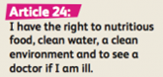  
Earth Hour: This is an event organised by the World Wide Fund for Nature (WWF). This is an opportunity for us to think about how we can care for our planet. You could talk to your child about recycling at home or turning lights off in your property.

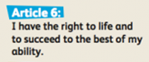

Recommended reading this month: