** Featherstone News**

**June 2023** 

Nursery News:

The Hatching Experience

What a wonderful experience for our children! We had 5 duck eggs and all of them hatched! We were able to learn so much about the duckling’s lifecycle and how they need to be cared for. They grew so quickly! They have now gone back to the farm and are being rehomed.

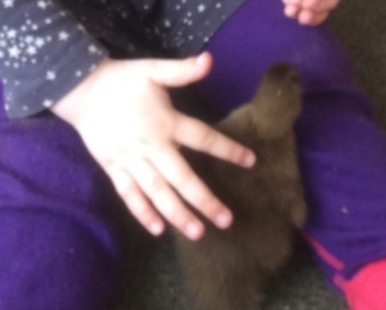 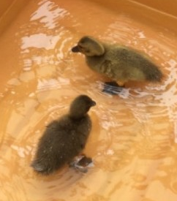

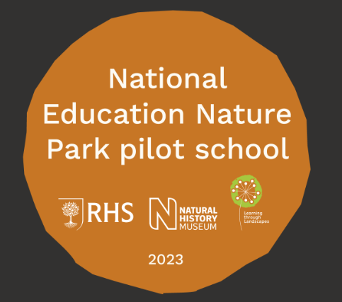

Our sessions have started with the National Education Nature Park project. The children have really enjoyed the outdoor activities so far. 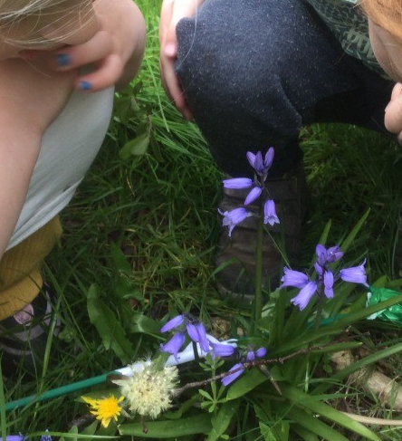

Dates for your diary:

Mondays at Osborne Nursery School – Stay and Play for under 2s. 9:45 – 11:15am

During June – working with Learning Through Landscapes Trust – outdoor workshops.

Monday 29th May – Friday 2nd June 2023 – Half term – nursery closed.

Monday 5th June 2023 – Nursery open

Wednesday 7th and Wednesday 28th June 2023 - Sally our artist is back! Look out for workshops dates on Tapestry

Wednesday 5th July – Robins, Caterpillars, Rabbits, Hedgehogs and Squirrels to Sutton Park with parents/ carers – details to follow.

Wednesday 12th July – Picnic morning or afternoon for our Acorn children with parents/ carers – details to follow

Wednesday 19th July 2023 – Leavers Celebrations!

Tuesday 25th July 2023 – LAST day of summer term.

z\\

 Attendance is very important at Nursery. We like to see you for all of your sessions each week. We like families to aim for attendance to be between 95 and 100%. Look out for the Cool Kittens stickers

Congratulations to Caterpillars AM and Ladybirds PM for the best attendance in Nursery in May 2023. FANTASTIC!! Well done to the parents and carers too. Aim for 95% or above!!

Concept Cat:

We will be continuing with Concept Cat next term. The children have enjoyed their sessions and have been using their new words in play. Thank you Liz!



Contact

**Contacting Nursery: Please remember to telephone us on 675 3408 if your child is too ill to be at nursery**



**Rights Respecting Schools Award (RRSA)**

June 20th 2023. World Refugee Day is held on June 20th. This is an annual event, held on the same date each year. World Refugee Day honours the strength and courage of refugees and encourages public awareness and support of the refugees, people who have had to flee their home lands because of conflict or natural disaster.

We have achieved the Silver Level of the Rights Respecting Schools Award (RRSA) and as part of this award we work with the children as well as with you to raise awareness about the UN Convention on the Rights of the Child.



Internet safety: We need to keep our children safe and help them to understand how to play games, use the internet and different devises safely.

A simple and effective way to get involved with your children and their lives online is through discussion. By maintaining an open dialogue with your child and encouraging them to talk to you about their internet use parents can help children access the amazing resources the internet has to offer whilst keeping them safe online.

C:\Program Files (x86)\Microsoft Office\MEDIA\OFFICE14\AutoShap\BD18234_.wmfC:\Program Files (x86)\Microsoft Office\MEDIA\OFFICE14\AutoShap\BD18234_.wmfC:\Program Files (x86)\Microsoft Office\MEDIA\OFFICE14\AutoShap\BD18234_.wmfC:\Program Files (x86)\Microsoft Office\MEDIA\OFFICE14\AutoShap\BD18234_.wmf

It is great to see the children bringing back their library books every Wednesday – we hope you are enjoying reading at home.

Recommended reading this month:

The Snail and the Whale by Julia Donaldson



One tiny snail catches a lift from a gigantic whale. They have all sorts of adventures and see the world. But when the whale is beached – who can save the day?!

There are lots of other lovely stories by Julia Donaldson!

**Transition:**

Many of our children will be leaving in July to start their Reception classes in their new schools in September. We are working closely with the schools to ensure that your child’s transition is as smooth as possible. In nursery we will be talking to the children about their new schools, looking at uniform and telling stories about what they could experience. Some teachers will also visit the stetting and we will provide reports to inform schools about their achievements.

Here are some top tips for home:

* Talk about their new school – draw pictures or talk about what they will be doing
* Talk about how they are feeling. It’s good to express feelings.
* What changes have they experienced in the past? ( New baby, new home?)
* Take a walk past their new school, talk about the route.

We hope everyone has enjoyed the half term break and you have managed to get out and about! We look forward to seeing you all on the week beginning 5th June 2023.