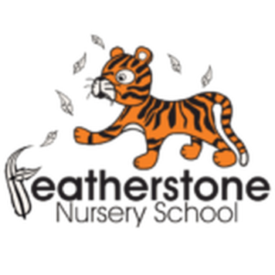 **Featherstone News**

**July 2023**

Dates for your diary:

July 2023 – Parents/ Carers please check Tapestry for your end of year reports.

Wednesday 5th July 2023 – 3 and 4 year olds visit to Sutton Park – parent/ carer to attend. Using the train as transport.

Thursday 13th July 2023 – Bumblebees and Ladybird trip to the local park – See Tapestry for details.

Wednesday 19th July 2023 – Leavers celebration!

Transition events through July – Please ensure you check emails and letters for visits to your child’s new school. Please let us know when you will be visiting.

July 2023 – Visits for new families at Nursery

Tuesday 25th July 2023 – Last day of the academic year.

Monday 4th and Tuesday 5th September 2022 – NURSERY CLOSED FOR STAFF TRAINING

Monday 30th October 2023 – Friday 3rd November 2023 – HALF TERM

Sally’s Art Workshops.

We love to be creative at Nursery but we have been lucky to have Sally back to teach us new skills! She was able to work with children and parents for two full days this term. Colours were mixed and fantastic sculptures made! Thank you Sally.

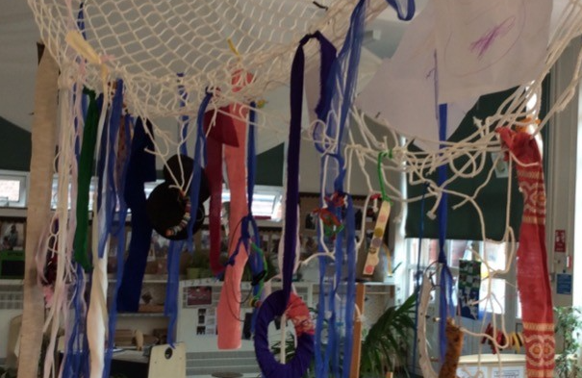

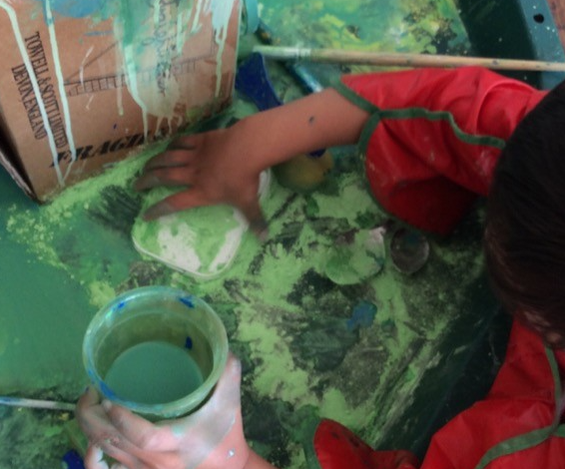

School Fund

Thank you to all the parents who are paying their school fund of £1 a week. In light of tightening school budgets, this enables us to pay for regular items such as breakfast, fruit snack, spare clothes and resources for celebration days. In previous years it has also been used to purchase gardening seeds, cooking ingredients and subsidise trips.

Please put any voluntary donations to school fund in the red letterbox by reception.

Parent Pay

Please ensure that your Parent Payments are up to date.

**Remember to telephone us on**

**0121 675 3408 if your child is too ill to be at nursery.** 

**Children returning to Nursery School in September 2023**

Children returning to Nursery School will come back in to school from **Wednesday 6th**

**September.** You will have a letter confirming your child’s pattern of attendance. We look forward to seeing you in September. Please remember to supply nappies and changes of clothes in a named bag.

Thank you.



We have achieved the Silver Level of the Rights Respecting Schools Award (RRSA) and as part of this award we work with the children as well as with you to raise awareness about the UN Convention on the Rights of the Child.

**Rights Respecting Schools Award (RRSA)**

July 2nd 2023 is National Thank You Day!

A day to celebrate all the things that keep us connected in our communities, saying ‘thank you’ to each other – making a cup of tea, sharing a cake, lighting up the BBQ, and getting everyone together.

Who can you say thank you today?!

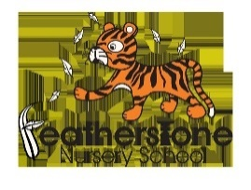

Internet Safety: Over the summer holidays please support your child when they use any devises like IPads or phones. Have a look at the advice below and keep your child safe. **Doing something is better than doing nothing – it is your responsibility**

* Speak to your internet provider if you are unsure. For detailed guidance on the different types of control, you can use this [online tool from Internet Matters](https://www.internetmatters.org/parental-controls/).
* Do not allow any devices in bedrooms – as parents go to sleep, children have a skill at re-awaking.
* Create rules around what’s OK and what’s not.
* Monitor websites and games before allowing children to surf and play freely.
* Ask them to take off headphones so you can listen in.
* Reduce screen time – encourage playing outdoors, sports and develop other interests.
* Talk to your child’s school, make sure academic work is up to date, look at their sleep habits.
* Always let your child know that they should always say if they see or hear anything online that makes them feel scared or uncomfortable and to never arrange to meet someone who they have met online.
* Let them know that they do not have to feel as though they have done something wrong, nobody is going to get cross and it is not their fault.

It is great to see the children bringing back their library books every Wednesday – we hope you are enjoying reading at home.

Recommended reading this month: Supertato!

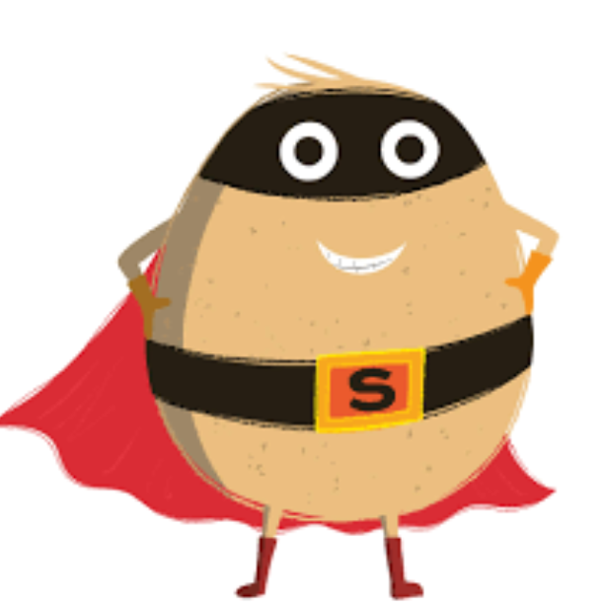

Meet Supertato! He's always there for you when the chips are down. He's the supermarket superhero with eyes everywhere - but now there's a pea on the loose. A very, very naughty pea. Has Supertato finally met his match?

These stories have been written by Sue Hendra and Paul Linnet.

Good luck to all of our children that are starting school in September. We have loved having you at our nursery! We look forward to seeing our returning children in September. We will be here ready to support your transition into new groups. We will also be welcoming new children and their families.

We hope you all have an enjoyable summer and remember to stay safe!