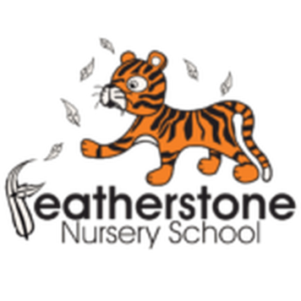 **Featherstone News**

**January 2023** 

Nursery News:

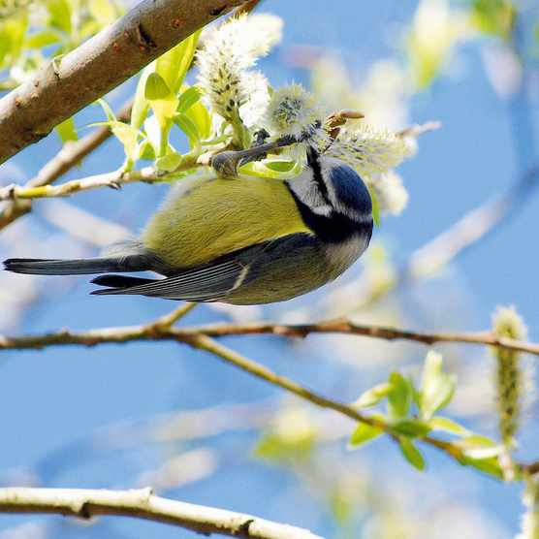

RSPB BIG BIRD WATCH 2022

We will be taking part in the RSPB Big Bird Watch. At Nursery we will be looking out for birds in our garden. We will count how many we can see and what species there are. You could do this at home too. Have a look at this web link to help!

<https://www.rspb.org.uk/get-involved/activities/birdwatch/>

**Please remember to telephone us on 675 3408 if your child is too ill to be at nursery.** Please keep us updated with any changes of address or phone numbers. Please let the Rachel or Rebecca know at our office.

Dates for your diary:

Tuesday 3rd January 2023 – INSET Training Day for staff, **nursery closed** for children

Wednesday 4th January 2023 – children return to nursery.

WC 23.01.23 – Playdough workshops for 2 year olds. Key workers will provide times and dates.

Reception places at Primary School.

Please ensure you have completed your application for your child’s Reception place for 2023. The closing date is 15th January 2023.

WC: 16th January 2023 -Luna New Year 

WC 23rd January 2022 – RSPB Big Bird Watch

**Real Objects Needed for our Home Corner**

We are trying to add more real objects into our home corner to give the children more realistic play experiences. The children do break these real objects but over time they learn to be more careful with them. If you have any old teapots, cups, saucers or small tea plates that you could donate to us we would be very grateful.

**Cold Weather:**

PLEASE remember to send your child to Nursery in a warm coat, gloves and a hat.

 Attendance is very important at Nursery. We like to see you for all of your sessions each week. We like families to aim for attendance to be between 95 and 100%. Look out for the Cool Kittens stickers

Congratulations to Robins and Bumblebees PM for the best attendance in Nursery in December 2022. FANTASTIC!! Well done to the parents and carers too.



**Rights Respecting Schools Award (RRSA)**

We have achieved the Silver Level of the Rights Respecting Schools Award (RRSA) and as part of this award we work with the children as well as with you to raise awareness about the UN Convention on the Rights of the Child.

This month ‘World Religion Day ‘is celebrated.

This is a day to recognise, respect and accept the hundreds of differing faiths across the globe.

This links to Article 2: The right not to be discriminated against and Article 14 : Freedom of thought , conscience and religion.

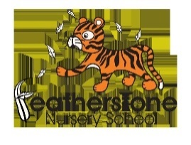

Internet safety: Each month we will be looking at using electronic devises safely at home. We need to keep our children safe and help them to understand how to play games, use the internet and different devises safely.

January’s message is: DOG LEAD – A lead gives a dog limits it can run to, in the same way set your child limits for how long they can go on line and what they are going on.

 

Curriculum focus: Traditional Tales Spring term 1.

This half term we will be exploring **traditional tales.** These are stories that have been retold over many years. They can be called fairy stories or fairy tales. Have you heard the story of’ Little Red Riding Hood’ or the story of ‘The Three Little Pigs’. It’s time to get reading!

Talk to your child about stories that they enjoy. What is your favourite story? Can they tell you the story? <https://www.bbc.co.uk/teach/school-radio/eyfs-listen-and-play-traditional-tales/zjjkbdm> - Use this link to listen to Cbeebies radio. This is a collection of stories from around the world.

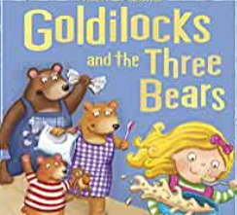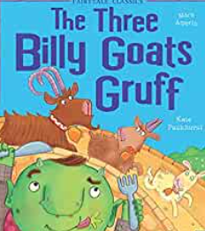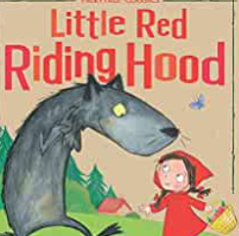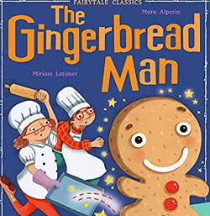

Key workers will provide you with a curriculum overview. This is so you are able to see what we will be learning about, key words to learn and activities you could do at home. If you have any questions please ask us!

We would like to wish all of our families a very happy new year!

We are really looking forward to welcoming new families into our Nursery this term. Take a look on Tapestry at what your child is doing at nursery and if you have any questions just ask your child’s key worker.