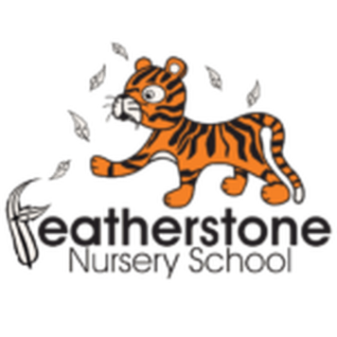 **Featherstone News**

**January 2022**

Nursery News:

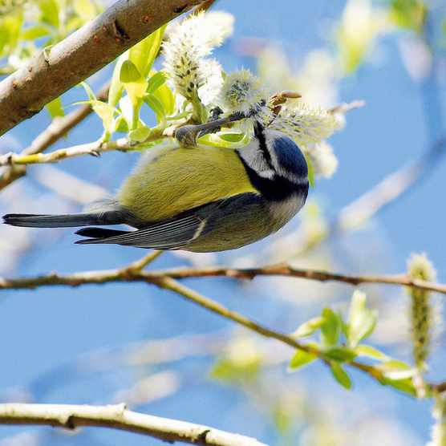

RSPB BIG BIRD WATCH 2022

We will be taking part in the RSPB Big Bird Watch. At Nursery we will be looking out for birds in our garden. We will count how many we can see and what species there are. You could do this at home too. Have a look at this web link to help!

<https://www.rspb.org.uk/get-involved/activities/birdwatch/>

**Please remember to telephone us on 675 3408 if your child is too ill to be at nursery.** Please keep us updated with any changes of address or phone numbers. Please let the Rachel or Rebecca know at our office.

Dates for your diary:

Tuesday 4th January 2022 – INSET Training Day for staff, **nursery closed** for children

Wednesday 5th January 2022 – **Children return to Nursery**

WC: 3rd January onwards 2022 – Welcoming new children into our setting

WC: 10th January 2022 – Forest School – Please check Tapestry for updates.

**Reception places at Primary School.**

Please ensure you have completed your application for your child’s Reception place for 2022. The closing date is **15th January 2022**.

WC 24th January 2022 – RSPB Big Bird Watch

**We will continue to follow these rules at Nursery:**

* **ALL** visitors to wear face coverings in the building, including parents.
* Parents to wear a face covering during settling sessions.
* Staff will wear masks in communal areas and continue to use lateral flow tests

( LFT)

* All children and adults will wash hands regularly
* All classrooms will be well ventilated

     

**Real Objects Needed for our Home Corner**

We are trying to add more real objects into our home corner to give the children more realistic play experiences. The children do break these real objects but over time they learn to be more careful with them. If you have any old teapots, cups, saucers or small tea plates that you could give us we would be very grateful.

**Cold Weather:**

PLEASE remember to send your child to Nursery in a warm coat.

**Parking reminder outside Nursery:** 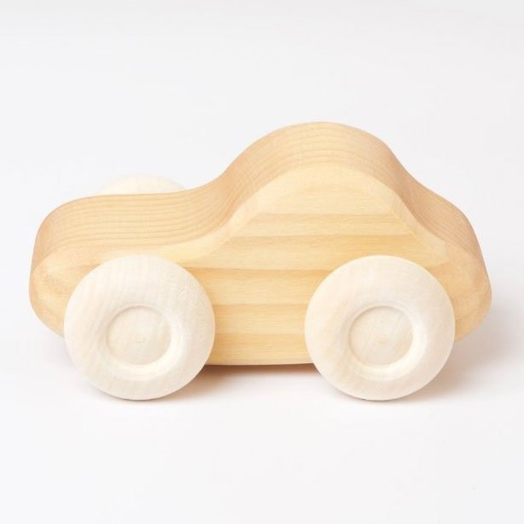

Please be respectful of our neighbours when parking outside nursery. Thank you.

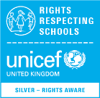

**Rights Respecting Schools Award (RRSA)**

We have achieved the Silver Level of the Rights Respecting Schools Award (RRSA) and as part of this award we work with the children as well as with you to raise awareness about the UN Convention on the Rights of the Child.

This month ‘World Religion Day ‘is celebrated.

This is a day to recognise, respect and accept the hundreds of differing faiths across the globe.

This links to Article 2: The right not to be discriminated against and Article 14 : Freedom of thought , conscience and religion.

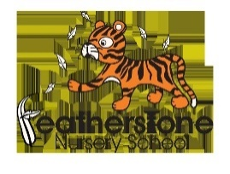

Safeguarding - Keeping children safe on-line

|  |
| --- |
| **UN Convention on the rights of the child.**  We will continue to talk to our children about staying safe on line.  We will be sharing the following with the children:  · I will tell an adult when I play on my device  · I will play games that I know  · I can turn on a device and switch off a device  · I know how to stay safe |

Hungry Little Minds Campaign

All the little things you do with your child – like everyday conversations, make-believe play and reading together – make a big difference to their development.

The Hungry Little Minds campaign provides lots of ideas that can help boost your child’s learning. You can slot them into your routine and your children will love them. Such as:

* Play ‘I spy’ on the bus with them and you can see their imaginations light up
* Talk to your child about what has happened so far in the day – for example, “We went to the shops this morning, didn’t we? We bought some apples.”
* And talk about what is going to happen next – “After lunch we’ll do the washing up”
* Look at picture books together. With each new page, give your child time to point out things to you and talk about what they can see

Search Hungry Little Minds for simple tips and activities, or to find out what’s available where you live.

**Traditional Tales**

This half term we will be exploring **traditional tales.** These are stories that have been retold over many years. They can be called fairy stories or fairy tales. Have you heard the story of’ Little Red Riding Hood?’ or the story of ‘The Three Little Pigs’. Talk to your child about stories that they enjoy. What is your favourite story? Can they tell you the story? <https://www.bbc.co.uk/teach/school-radio/eyfs-listen-and-play-traditional-tales/zjjkbdm> - Use this link to listen to Cbeebies radio. This is a collection of stories from around the world.

**We would like to wish all of our families a very happy new year!**

We are really looking forward to welcoming new families into our Nursery this term. Take a look on Tapestry at what your child is doing at nursery and if you have any questions just ask your child’s key worker.