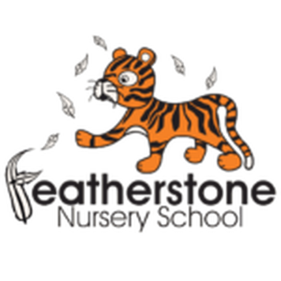 **Featherstone News**

**January 2020**

Dates:

Tuesdays and Fridays from 21st Jan to 14th Feb – **Sally our** **Artist in Residence** will be working with all the children in nursery

Tuesday 4th Feb – **Keeping Healthy Workshops** - 10:45-11:30am and 2:30-3:30pm

Wednesday 5th Feb – **Life Education Caravan**

Thursday 6th Feb – **Keeping Healthy Workshop** –2:30-3:30pm

Wednesday 12th Feb – **Little Red Hen** – drama workshop for our 3-4 year olds by The Play House

17th – 21st Feb – **Half Term Holiday**

www.featherstonenurseryschool.org.uk

Nursery News:

A happy new year to everyone, we hope 2020 will be a good year for you all!

We are having some new children join us this month so a huge welcome to them and their families. Take a look on Tapestry at what your child is doing at nursery and if you have any questions just ask a member of staff.

Cool Kittens for December

with the best attendance were

**Rabbits pm Group**

with 84%

average attendance



Real Objects Needed for our Home Corner

We are trying to add more real objects into our home corner to give the children more realistic play experiences. The children do break these real objects but over time they learn to be more careful with them.

If you have any old teapots, cups, saucers or small tea plates

that you could give us we would be very grateful.



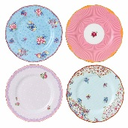

Keeping Healthy Workshops

In the week beginning 3rd February we will be having a focus week on keeping ourselves healthy. The Life Education Caravan will be visiting us on the Wednesday and all children will get the chance to visit Harold the Healthy Giraffe in the caravan.

We’ll also be running some workshops for parents and their child to attend together. More details will follow but these sessions will involve cooking a healthy snack together!

Reception Place Deadline

If your child is going to be 4 years old by 31st August 2020 please ensure that you have done an online application for a school place.

This must be completed by 15th January or you may not get any of your choices for a primary school place, even if you have an older child at the school.

Please speak to our office staff if you need help with the application process.





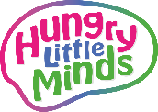

Hungry Little Minds Campaign

All the little things you do with your child – like everyday conversations, make-believe

play and reading together – make a big difference to their development.

The Hungry Little Minds campaign provides lots of ideas that can help boost your child’s learning. You can slot them into your routine and your children will love them. Such as:

* Play ‘I spy’ on the bus with them and you can see their imaginations light up
* Talk to your child about what has happened so far in the day – for example, “We went to the shops this morning, didn’t we? We bought some apples.”
* And talk about what is going to happen next – “After lunch we’ll do the washing up”
* Look at picture books together. With each new page, give your child time to point out things to you and talk about what they can see

Search Hungry Little Minds for simple tips and activities, or to find out what’s available where you live.

**Things we are learning at nursery**

**and ways you can help us at home**

3-4 year olds

We’ll be doing lots of activities this month that involve size and measurement language, such as tallest, shortest, longer than, enormous, tiny etc.

There are lots of traditional tales that explore size such as Jack and the Beanstalk or Goldilocks and the 3 Bears. Try sharing one of these stories together at home and helping your child practise this maths language.

Largest bear, middle sized bear & smallest bear

2 year olds

We’ll also be looking at size this month and finding things that are big and small. We’re also still working on our turn taking.

Try taking it in turns with your child to add a block to build a tower. Which tower is the big / tall tower? You could also make towers out of cushions, Duplo or cardboard boxes.

Can you make a tower that is as tall as your child? Take a photo and put it on Tapestry so we can see.

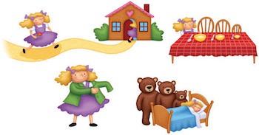

Artist in Residence – Sally

This half term Sally will be building on the work she started with the children in December. She will be coming twice a week develop the children’s creativity skills by using a range of natural objects.

Look at some of the fantastic work we did last term with Sally:

