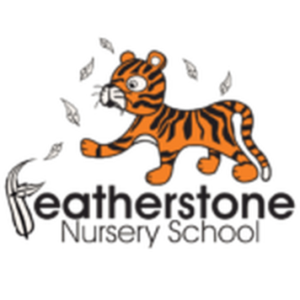 **Featherstone News**

**February 2023** 

Nursery News:

Thank you to all of our parents and carers that came to the 2 year old playdough workshops! We hope that you enjoyed them as much as we did and can now make the playdough at home to strengthen their little hands and to get creative.



Sally will be visiting again in February. Sally is responsible for coordinating the wonderful art work at the front of our school. Sally is busy planning our next artistic adventure – we can’t wait to work with her again!

The Play House Theatre will be visiting again to perform ‘Anansi’ for our 3 and 4 year olds. We will be learning about the story and participating in different learning activities linked to the events.

Dates for your diary:

Wednesday 1st February 2023 – The Play House Theatre will be visiting our nursery for our 3 – 4 year olds.

Wednesday 8th February and Wednesday 15th February 2023 - Sally our artist is back! Look out for workshops dates

Monday 20th February – Friday 24th February – Nursery closed HALF TERM

Wednesday 1st march 2023 – Dressing up as our favourite book character for World Book Day! Reading workshops – times TBC

Easter holiday – Monday 3rd April– Friday 14th April 2023

Nursery open on Monday 17th April 2023

Contact

**Contacting Nursery: Please remember to telephone us on 675 3408 if your child is too ill to be at nursery.** Please keep us updated with any changesof address or phone numbers. Please let the Rachel or Rebecca know at our office.

Cold Weather:

PLEASE remember to send your child to Nursery in a NAMED warm coat, gloves and a hat. Please supply a change of clothes too – sometimes the children may get wet or dirty and we will change them into dry, clean clothes when needed. Thank you.

 Attendance is very important at Nursery. We like to see you for all of your sessions each week. We like families to aim for attendance to be between 95 and 100%. Look out for the Cool Kittens stickers

Congratulations to and for the best attendance in Nursery in January 2023. FANTASTIC!! Well done to the parents and carers too.



**Rights Respecting Schools Award (RRSA)**

We have achieved the Silver Level of the Rights Respecting Schools Award (RRSA) and as part of this award we work with the children as well as with you to raise awareness about the UN Convention on the Rights of the Child.

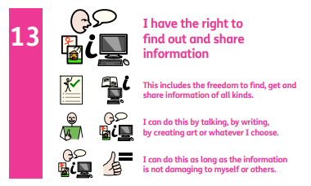



Internet safety: Each month we will be looking at using electronic devises safely at home. We need to keep our children safe and help them to understand how to play games, use the internet and different devises safely.

PLUG

Its ok to UNPLUG for a few hours – children needs break and should be encouraged to do something else. They could play with toys, visit family/ friends or run around outside. You’ll both bebfit if you ignore the messages on your phone whilst playing or talking with your child. ( You’ll save some elecrticty too!)



Teaching our children to become independent.

Routines really help a child to understand what is expected of them and what they will be doing next. At nursery we have routines and have pictures to help them understand what is coming next.

You can help with this at home. Be clear about your morning routine. It could look like this:

* Get up!
* Wash and brush teeth
* Get dressed
* Have breakfast
* Go to nursery

Encourage your child to carry out these tasks by themselves.

Children also enjoy having responsibilities too– this could be setting the table or sorting their toys.



Toilet Training: Congratulations to all the children that are dry during the day at nursery. We know children will have little accidents but it is important that they learn to use the toilet. Please support them at home to wear pants, use the toilet and wash their hands. 

https://www.nhs.uk/conditions/baby/babys-development/potty-training-and-bedwetting/how-to-potty-train/

It is great to see the children bringing back their library books every Wednesday – we hope you are enjoying reading at home.

Recommended reading this month:

Have a read of this cheeky tale! It will make you chuckle! You will be able to find this book in the library and there are videos on line. Send a message on Tapestry to let us know what you thought of the story!

Well done to all the children that have started nursery in January. They are settling well and getting to know the staff and routines. If you have any questions, please speak to a member of staff and keep checking Tapestry for updates.

We hope our families have enjoyed celebrating Luna New year!