** Featherstone News**

**February 2022**

Nursery News:

We have welcomed many new families to Nursery this month. The children have settled really quickly and are now enjoying lots of different activities. Remember if you have any questions or need any advice please speak to your child’s key worker.

We will be learning about different customs and events involving Lunar New Year this week. It is the year of the tiger.

The children will be creating their own dragon dances and talking about celebrations that are special to themselves and their families.

Birmingham Forward Steps – Children’s Centres: Wellbeing sessions at Featherstone Children’s Centre **THURSDAYS 10 – 12.** This is a session called ‘Hug in a Mug’ a time to chat and talk about the 5 ways to Wellbeing.

**Walking for Well-Being Group** – group walking for parents and young children in our local parks – Sutton, Central and Witton Lakes. Please see Tapestry for details, talk to a member of staff or call 0121 7521870.

Dates for your diary:

**Tuesday February 1st 2022** **– Luna New Year. Celebrations focus in Nursery.**

**Wednesdays in Cherry room**: **Sally our** **Artist in Residence** will be working with all the children in nursery. Look out for photos of their work on Tapestry.

**Monday February 21st – Friday February 25th 2022** – **Half Term Holiday-Nursery closed.**

**Monday 28th February 2022: Nursery is open to children**

**Thursday March 3rd 2022: World Book Day**

**We will continue to follow these rules at Nursery:**

* **ALL** visitors to wear face coverings in the building, including parents.
* Parents to wear a face covering during settling sessions.
* Staff will wear masks in communal areas and continue to use lateral flow tests

( LFT)

* All children and adults will wash hands regularly
* All classrooms will be well ventilated

     

**Reminders!**

**Cold Weather:**

PLEASE remember to send your child to Nursery in a warm coat with a pair of gloves.

**Nursery Library Books**

**We love to read at Featherstone!**

Please can you all remember to bring your child’s library book back to nursery each week on a Wednesday so that it can be changed?

**Please remember to telephone us on 675 3408 if your child is too ill to be at nursery.** 

Please keep us updated with any changes of address or phone numbers. Please let the Rachel or Rebecca know at our office.

**Parking reminder outside Nursery:** 

Please be respectful of our neighbours when parking outside nursery. Thank you.



**Rights Respecting Schools Award (RRSA)**

We have achieved the Silver Level of the Rights Respecting Schools Award (RRSA) and as part of this award we work with the children as well as with you to raise awareness about the UN Convention on the Rights of the Child.

This month is **Safer Internet Day.** This day calls upon young people, parents, carers, teachers, social workers, law enforcement, companies, policymakers and wider to join together to make a better internet.

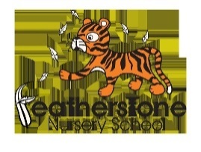

Safeguarding - Keeping children safe on-line – 9th February 2022

|  |
| --- |
| **UN Convention on the rights of the child.**  We will continue to talk to our children about staying safe on line.  We will be sharing the following with the children:  · I will tell an adult when I play on my device  · I will play games that I know  · I can turn on a device and switch off a device  · I know how to stay safe  Take a look at cbeebies website – you can find short videos giving advice about making the internet safer. They are also useful for older children in your household too. |

Helping your child at home:

2 year olds

We’re learning to look after our bodies ourselves by going to the toilet, washing our own hands, pouring ourselves a drink of water and putting our coats on when it’s cold outside.

Please support your child’s attempts at these things at home with lots of praise and encouragement.

3-4 year olds

We’ll be doing lots of activities this month around keeping healthy, such healthy eating, brushing our teeth, sleeping and being physically active. You could talk about the foods you eat at home or exercise that they enjoy.

See how many ways your family can be healthy this month at home? Put some photos on Tapestry for us to talk to your child about e.g. of you all trying different healthy foods or going for a walk.

World Book Day:

This year Wold Book Day will be celebrated on March 3rd 2022. We always enjoy new books and stories at Nursery but there will be a big focus on reading during this week. Look out for pictures on Tapestry and extra activities we will be doing. Talk to your child about their favourite story and why. We will be handing out the £1 book tokens during WC 28.02.22.

There are lots of resources on their website: <https://www.worldbookday.com/share-a-story-corner/>

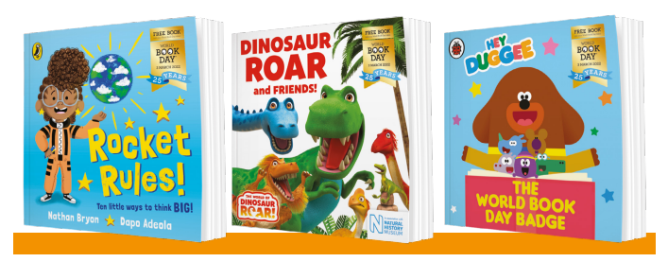

**We would like to wish all of our families celebrating a very happy LUNA new year!**