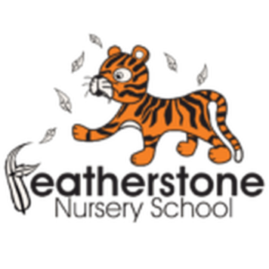 **Featherstone News**

**December 2021**

Dates:

Wednesdays in Nov & Dec – Sally, our artist in residence, will be working with our 3-4 year olds in nursery.

WC: 6th December – Wear your Christmas jumpers or something red! ‘Save The Children ‘ charity.

Tuesday 14th and Thursday 16th – Christmas dinner.

Wednesday December 15th 2021 – Christmas parties!

Friday 17th December – Children break up from Nursery

Tuesday 4th January 2022 – INSET Training Day for staff, **nursery closed** for children

Wednesday 5th January 2022 – **Children return to Nursery**

Nursery News:

**Nursery Rhyme Week:**

It was lovely to see parents supporting us with Nursery Rhyme week – thank you to those parents that could attend. The children really enjoyed all of the activities and could talk about their favourite rhymes. Please have a look at the photos on Tapestry!

**Road Safety Week.**

The children have been learning about how to keep safe on our roads. They have been looking at different signs we see on our streets and talking about how to stay safe. They have also learnt a song about it too! Talk to your child about road safety.

**Updates on Tapestry:**

As you may be aware changes were made to the Early Years Guidance in September 2021. To adhere to the changes made, we will provide parents and carers with a termly report about children’s successes and areas to develop. These will be published on Tapestry.

We also provide an insight into Nursery life on a weekly basis so look out for those photographs too!

**Please remember to telephone us on 675 3408 if your child is too ill to be at nursery.** 

Due to the prime ministers announcement and guidance from the DFE we have implemented temporary measures at Nursery:

* **ALL** visitors to wear face coverings in the building, including parents.
* Parents to wear a face covering during settling sessions.
* Staff will wear masks in communal areas and continue to use lateral flow tests

( LFT)

* We will reduce the amount of visitors into school from Tuesday 30th November onwards

     

**Reception places at Primary School.**

Please ensure you have completed your application for your child’s Reception place for 2022.

The closing date is 15th January 2022. If you miss this deadline you are less likely to be offered a place at your preferred school. If you need any help or advice please speak to your child’s Key Worker.

Please visit: www.birmingham .gov.uk to apply online for a place. You will also find clear guidance to help.

**Parking reminder outside Nursery:** 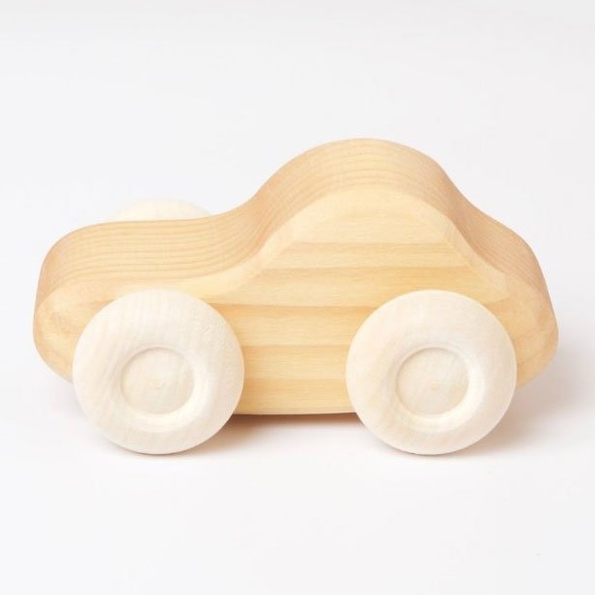

Please be respectful of our neighbours when parking outside nursery. Thank you.



**Rights Respecting Schools Award (RRSA)**

We have achieved the Silver Level of the Rights Respecting Schools Award (RRSA) and as part of this award we work with the children as well as with you to raise awareness about the UN Convention on the Rights of the Child.

Stripey has been on some lovely adventures so far and the children have enjoyed sharing their news. Stripey had a visit to Hardip’s house. He learnt about his rights and was helped to feel safe and secure. He also enjoyed a tasty meal.

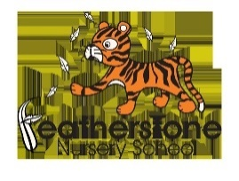

Safeguarding - Keeping children safe on-line

|  |
| --- |
| As part of our teaching and learning around keeping safe we also need to focus on keeping safe online. Remember you wouldn’t leave your child alone in a park unsupervised so similarly young children shouldn’t be left unsupervised alone on the internet. Children are only 3 clicks away from inappropriate material- so please use apps such as YouTube Kids with your child even if they are watching recommended videos.  **UN Convention on the rights of the child**  **Article 17**- you have the right to get information that is important to your well-being from books, computers and other sources. Adults should make sure that the information is not harmful and help you find and understand the information you need. |

Startwell:  

We have been learning about ‘Smiley Shen’. She encourages us to brush our teeth and keep them clean. We have learnt that our first set of teeth are really important and they help us to learn to eat, chew and speak. Make sure you brush your teeth at home too! 

Startwell:  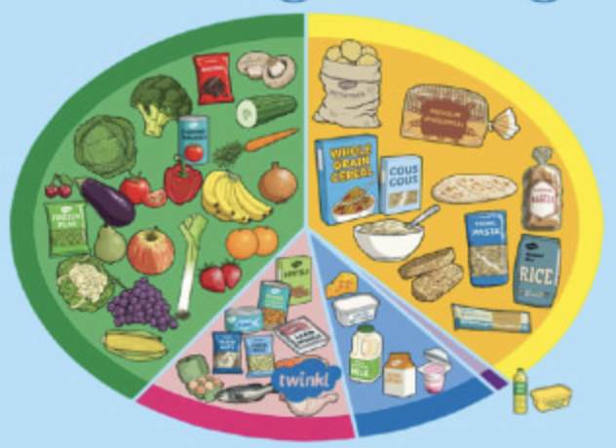

Mickey Size Me will teach us all about portion sizes for toddlers and young children. We know children have smaller stomachs so should be eating smaller portions regularly. We need to fill their stomachs with nutritious foods! **Talk** to your child about the food they like and the foods we need to eat to give us energy every day!

Early Words Together.

Thank you to all those parents and carers that took part in our Early Words Together workshops with Menaz. We have received some lovely feedback from parents and children about the activities and importance of talking to and playing with your child. Look out for our workshops in the Spring term 2022!

The Staff and Governors hope you all have an enjoyable break and we would like to wish those celebrating, a very happy Christmas.