** Featherstone News**

**December 2019**

Nursery News:

We apologise for the lack of heat in our reception area as you come into nursery. The boiler in the Children’s Centre side of the building has been giving us a lot of problems, but this should be being fixed soon (we hope!)

Dates:

Monday 9th Dec – **Winter Workshop** – children with a parent or carer at 2:30pm

Thursday 12th Dec – **Winter Workshop** - children with a parent or carer at 2:30pm

13th & 16th Dec – **Christmas dinners**

Tuesday 17th Dec – Hedgehogs & Robins parents join your child at their story time (2.10pm) for a **Christmas sing-a-long**

Thursday 19th Dec - Parents join your child at their story time (11.10am, 2.10pm or 3.10pm – ask your keyworker for your group’s time) for a **Christmas sing-a-long**

Wednesday 18th Dec – **Christmas parties** in am and pm sessions

23rd Dec to 3rd Jan - **Christmas holidays**

Monday 6th Jan – INSET Training Day for staff, **nursery closed** for children

Tuesday 7th Jan – All children return to nursery

www.featherstonenurseryschool.org.uk





Cool Kittens for November

with the best attendance were

**Robins Group**

with 88%

average attendance





Christmas Sing-a-long

On Tuesday 17th (Hedgehogs & Robins) and Thursday 19th December join your child at their story time for a Christmas

sing-a-long.

Check with your child’s keyworker for the time of their group’s story time (usually in the last 20 minutes before they go home.) So just come a little earlier to pick them up and join in the fun. The children love to see their parents / carers joining in at nursery!



Winter Workshops

On Monday 9th and Thursday 12th December join your child at 2:30pm for an hour of craft activities led by our Artist in Residence, Sally. If your child usually goes home at that time they can stay if an adult joins them. Sally has some great Christmas decoration activities planned.

There is no cost for the session, however there will be refreshments and items for sale which will hopefully raise some money for the nursery.

Christmas Party

On the last Wednesday of term (18th December) we’ll be having our Christmas parties. On this day the children need to attend nursery at their usual times.

We’ll be having party food, lots of games and a visit from Father Christmas.

Please see your child’s keyworker

if you can donate food for a party.





Box Modelling

Please collect small empty boxes, tubes and shiny chocolate wrappers over the holidays and bring them to nursery in January. The children love recycling these into models and pictures.

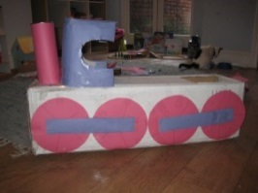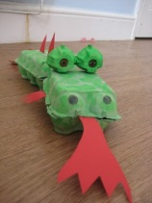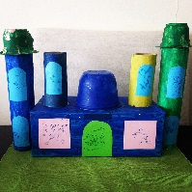

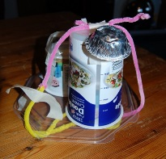

Health for Life in Nursery Schools

In January we are starting an exciting initiative funded by the Cadbury Foundation which is part of a broader commitment to help make “a sustained, demonstrable improvement in healthy lifestyles across Birmingham.” The programme will support nursery schools by engaging their school community in healthy, active lifestyles.

We’ll be introducing a number of new activities, such as Dough Disco, a balance bike loan system and family challenges. All the activities will be aimed at encouraging us all (children, parents/carers and staff) to be more active.

We’ll keep you informed about all the new activities through our newsletters and

on our school website.



Parent’s Information Stand

Please have a look at our new parent’s information stand on the top of the cupboard as you come into nursery.

The ‘Welcome to Featherstone’ book will have photos added throughout the year and will give you a flavour of what happens at nursery.

Please also add your comments to the ‘Comments Book’ – positive comments and suggestions for how we can improve are welcome.

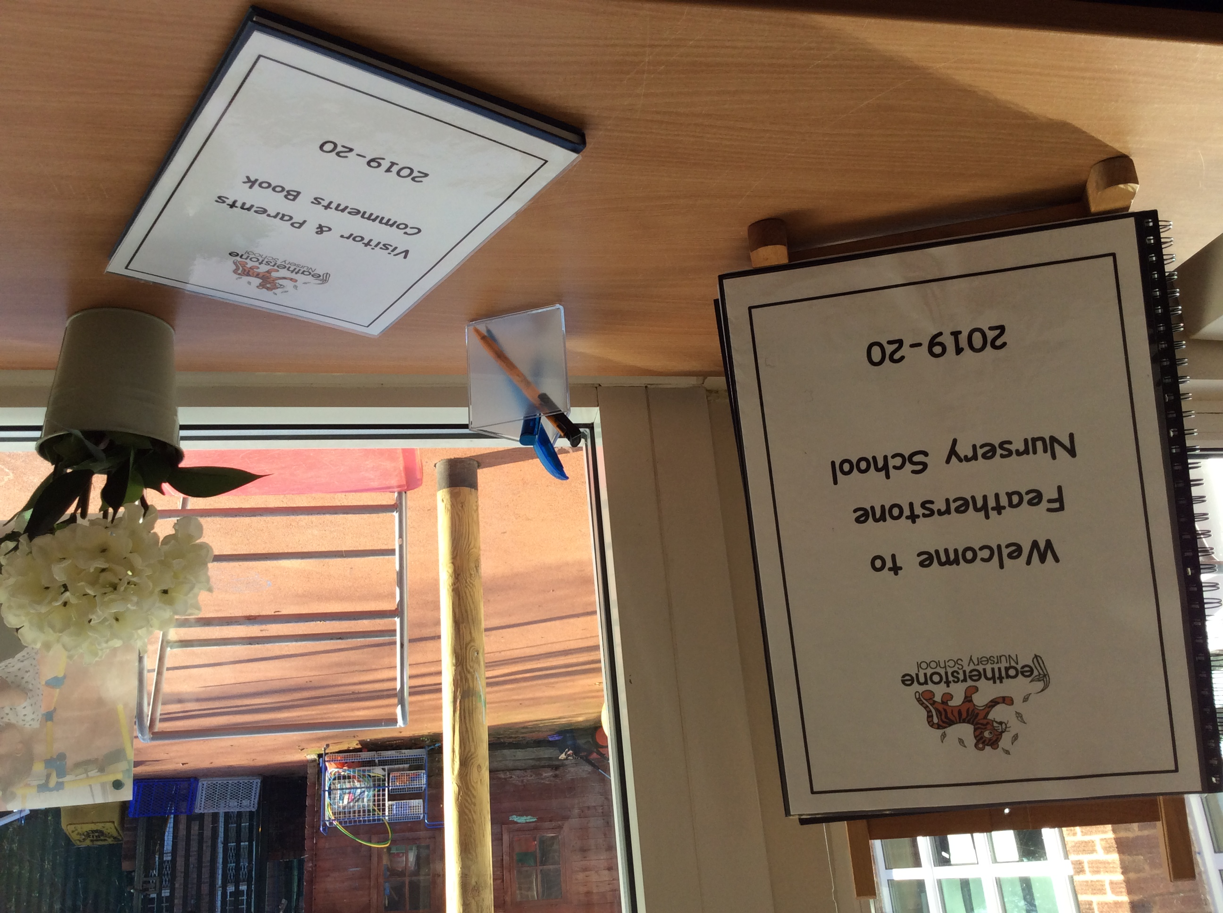

The Staff and Governors would like to wish you all a very happy Christmas!