** Featherstone News**

**April 2023** 

Nursery News:

World Book Day was a real success! Thank you to everyone who dressed up as their favourite character! So many stories were shared and talked about. We hope you have manager to use your free voucher too.

Nursery Repairs:

Thank you for your patience during the Spring term – we now hope that we do not have any more leaks and the nursery can run as normal.

Spring Fair!

Wow! Thank you so much for your support. The event was a great success – we will let you know how much we raised. The cakes and samosas sold out so quickly and there were lots of happy faces when winning prizes. We look forward to our next event!

Easter holiday – Monday 3rd April– Friday 14th April 2023

Nursery open on Monday 17th April 2023

Sunday 16th April – Reception places announced – please let nursery know.

WC 17th April – Welcoming new children into Nursery!

During April and May – working with Learning Through Landscapes Trust – outdoor workshops.

WC: 24th April - The hatching experience! The eggs will arrive to start our project about growth and change for the summer term.

Monday 1st May – May Bank Holiday

Monday 8th May – Closed – Bank holiday – King’s Coronation.

Monday 29th May – Friday 2nd June 2023 – Half term – nursery closed.

Wednesday 7th and Wednesday 28th June 2023 - Sally our artist is back! Look out for workshops dates.

z\\

 Attendance is very important at Nursery. We like to see you for all of your sessions each week. We like families to aim for attendance to be between 95 and 100%. Look out for the Cool Kittens stickers

Congratulations to Robins and Bumble Bees PM for the best attendance in Nursery in March 2023. FANTASTIC!! Well done to the parents and carers too. Aim for 95% or above!!

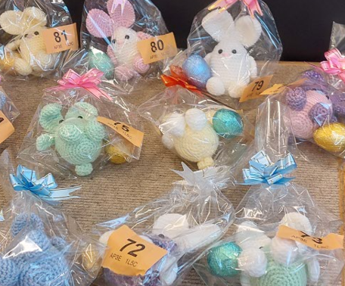 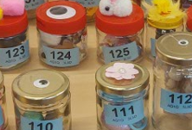

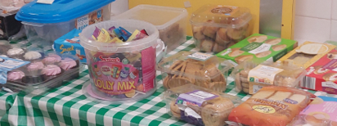

Contact

**Contacting Nursery: Please remember to telephone us on 675 3408 if your child is too ill to be at nursery**



**Rights Respecting Schools Award (RRSA)**

We have achieved the Silver Level of the Rights Respecting Schools Award (RRSA) and as part of this award we work with the children as well as with you to raise awareness about the UN Convention on the Rights of the Child.

World Heath Day is held on the 7th April every year. This day is dedicated to promoting the benefits of good health and wellbeing worldwide. How do we look after our own mental health? This year’s theme is “Health for All ”



Internet safety: We need to keep our children safe and help them to understand how to play games, use the internet and different devises safely.

Cbeebies has a lovely Reading App that you can down load. **How can it help your child?** 

* Children are exposed to different types of stories
* They can practise comprehension
* They can follow along with the stories if they are not yet reading.

Remember to monitor what your child is doing on line, give time limits and ensure that you have safety settings on your devises.

April 2022: **Autism Awareness Day**. Date: 29th March – April 4th 2023

What is it: Day is intended to bring the world’s attention to autism, a pervasive disorder that affects tens of millions, by encouraging member states to take measures to raise awareness about autism throughout society and to encourage early diagnosis and early intervention. <https://autismwestmidlands.org.uk/online-resources/>   
**Rights Link: Article 2 Non-Discrimination.**

**World Health Day.** Date: 7th April 2023  
What is it: World Health Day is held to mark the founding of the World Health Organisation in 1948 and is seen as an opportunity to draw worldwide attention to a subject of major importance to global health.



It is great to see the children bringing back their library books every Wednesday – we hope you are enjoying reading at home.

Recommended reading this month:

Oliver’s Vegetables by Vivien French.

What are your favourite foods? Oliver plays a game with his grandad in the garden – what foods will he eat?! Enjoy reading this book together – talk about the pictures and the different vegetables Oliver tastes!

Look out for our stories on Tapestry – we will reading a book from our termly plans each week and teaching a new makaton sign.



We hope that you all enjoy the 2 week break. Eid Mubarak and happy Easter to those that celebrate. Please check Tapestry for your child’s termly report and for photos of all the  lovely learning experiences the children are having here! 